**Market Segmentation for**

***Senses* Coffee company**

Hayfa Bu Hazzaa

1. **Introduction**
   1. **Background**

Senses is a coffee company that produce three brands of coffee, Ellite, Instance, and Chill. It is based on US. The owners and shareholders decided that it is the time to expand and penetrate another market. Canada is the first option to investigate since it is near to US and the market is somehow similar in taste to US, so no need to customize the product to suite the target country culture. Canada is very big country that is why it was initially decided to dedicate three offices to manage the operations in the country. Also it was decided to focus on specific market segments which are Hotels, Bakeries and Grocery Stores. The reasons of this selection are:

1. Senses Coffee has three main coffee brand that dedicated to Hotels, Bakeries and grocery stores.

|  |  |
| --- | --- |
|  | *Ellite* is fine coffee suitable for hotels markets, |
| Coffee top draw for donut shop customers | 2020-01-08 | Food ... | *Instance* is average coffee that is suitable from taste and price for Bakeries markets, |
| Single Door Fridge With Ice Maker: Best Iced Coffee Grocery Store | ***Chill*** is an iced coffee that is very popular with good price and suitable for Grocery stores markets. |

1. Canada is a very big country, and to penetrate it you need first to test the market and focus on the most venues that would generate good money.

The company investors are willing to invest in Canada market, but still need to see solid data about Canada market and specifically about the three market segments it will target. To be able to estimate the amount of the investment needed based on the initial market size. Data scientist team was hired to provide the investors with needed data. Data scientist team will need to collect the concerned data, clean it and then analyse it, this shall provide the needed insight for the investors.

* 1. **Problem**

Senses Coffee company hired data scientist to collect and analyse the data based on geo-demographic market segmentation. to provide insight that will drive the decision of entering the Canadian market and segment it across the three operation offices.

Essential data which will contribute to the market segmentation process includes: Canadian municipalities, Canadian municipalities’ geographical coordinates (i.e. the longitudes and latitude data of the municipality), and the number and the category of potential customers in each municipality like hotels, Grocery Store and Bakery).

This project is a data clustering project and it is aimed to segment the Canadian municipalities into three marketing segments (i.e. 3 clusters). Although the above-mentioned data will contribute in the segmentation process, the segmentation itself will be done according to the number and the category of potential customers in each municipality (i.e. the number of hotels, the number of Grocery stores and the number of Bakeries). In this approach, each operation office will operate a single of the new market.

Figure 1 below views an example of the potential market segmentation, and Figure 2 views an example of a geo-demographic market segmentation based on this descriptive analytics data clustering approach.

**Figure 1 - Potential market segmentation**

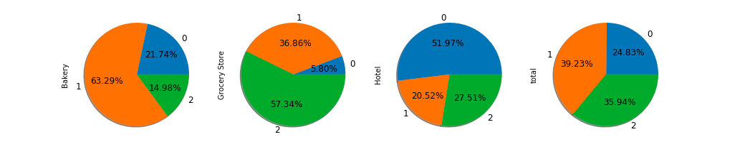

**Market Segment 0**

**(Municipality Cluster 0)**

**Market Segment 1**

**(Municipality Cluster 1)**

**Market Segment 2**

**(Municipality Cluster 2)**

**Market Segments distribution % across Clusters**

**Figure 2 - Geo-demographic market segmentation**

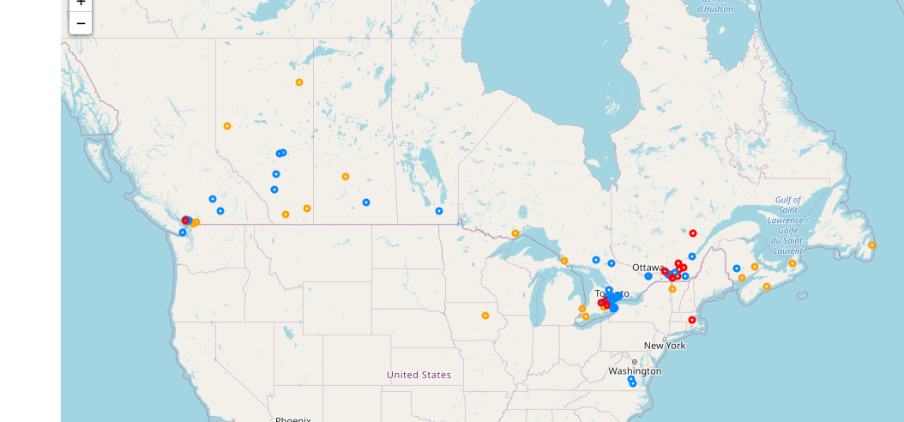



* 1. **Interest**

Senses Coffee company needs to select the municipalities that will be targeted by operation offices. Therefore, the company management and operation offices are interested to know the size of the new potential market in each segment. Other audiences who care about this problem include the company shareholders and Human capital department (see Table 1 below for an example).

**Table 1 - An example of potential market segment size**

**(expressed in number of customers in each business line in each cluster)**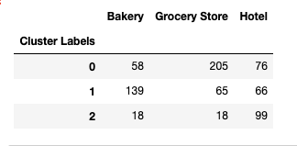

1. **Data acquisition and cleansing**
   1. **Data sources**

Table 2 below describes the datasets used to build the clusters and their corresponding data sources.

**Table 2 - the datasets and their data sources**

|  |  |  |  |
| --- | --- | --- | --- |
| **No** | **Dataset** | **Description** | **Data Source** |
| 1 | List of the largest 100 municipalities in Canada | Data fields include Municipalities, Province, Growth rate and population. See Appendix I for an example of this dataset. | I scraped the following Wikipedia site to obtain this data  <https://en.wikipedia.org/wiki/List_of_the_100_largest_municipalities_in_Canada_by_population> |
| 2 | Geo-Location data of each municipalities in Canada | Data fields include the longitude and latitude coordinates of each municipality. See Appendix II for an example of this dataset. | I obtained this data using the Python geocoding web services API. |
| 3 | Potential customers’ data | Data fields include the venue name, category, longitude and latitude, See Appendix III for an example of this dataset. | I obtained this data by exploring the municipality’s venues using the Foursquare API |
| 4 | Canada map GIS data | Data of Canada with the largest municipalities. See Appendix IV for an example if this dataset. | I obtained this data using the Folium API |

* 1. **Data Cleansing**

I followed below steps to clean the data in order to be ready for further analysis.

1. I scraped the data of 100 largest municipalities in Canada from the Wikipedia page using Python. After investigation, I discovered that the column names in the Wikipedia page are not put in standard naming convention. a column name Population(2016) use special characters, and this jeopardize the Python program code. So, I modified the column name to Population2016 to include only the standard alphabetic character set.
2. I inserted the latitude and longitude coordinate columns structure to the data frame structure of the table read from the Wikipedia page.
3. I added the coordinates data from the geocoding web services and include it in the data frame.
4. Then I checked for any missing coordinates to drop nan values cells. Fortunately, all coordinates data were successfully retrieved by the API. Then I combined the venue data with the location data and the master data acquired from the Wikipedia (Table 3).
5. I then used Folium to create Canada map with all municipalities superimposed on top and used this map to visually verify the correctness of acquired data on the map (see Appendix IV).

**Table 3 - Combined Wikipedia data, location data and venue data**

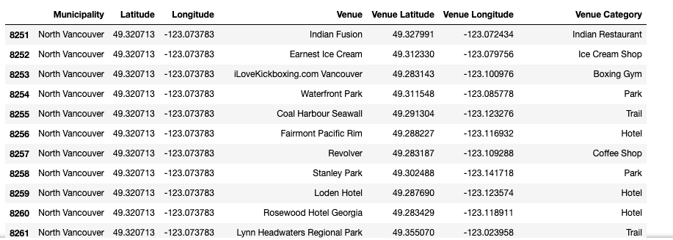

* 1. **Feature Selection**

After data cleansing, there were 8719 venues listed under all categories. First, I took out the duplicated rows it was 100 rows and I took it out. To end up with total 8619 venues. Then I listed the unique categories (310 unique categories), this is important to select the right category name that I need to keep and drop others.

**Table 4- the first 10 rows in the venue categories**

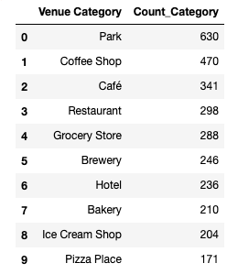

The above table gives the confidence that the Canadian market is good and there are many potential hotels, Grocery stores and Bakery in Canada. Then I dropped all venues except the venues with categories (Hotels, Grocery Store and Bakery), the numbers of each venue category are shown in table 4.

**Table 4 – Venues counts of Grocery Store, Hotels, Bakery**

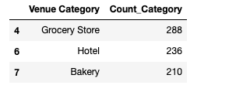

1. **Methodology**
   1. **Exploratory data analysis**
      1. **Master dataset**

The master dataset includes Canada municipalities, the province, Growth rates, Population 2016, and the municipalities coordinates (longitude and latitude). After combining the master dataset as explained in section 2, the master dataset was explored by printing the master dataset data frame, obtaining its summary information and displaying each municipality on Canada map. Table 5 shows a sample of the master dataset and its attributes. Figure 3 shows that the master dataset includes 100 municipalities, and Figure 4 depicts the location of each municipality on Canada map.

**Table 5 - Sample of the master dataset and the master dataset attributes**

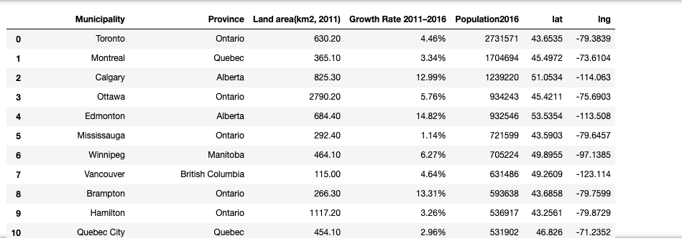

**Figure 3 – Master Dataset Information (100 Municipalities)**

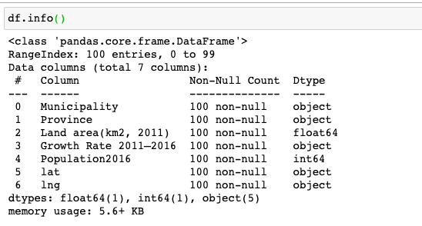

**Figure 4 –Location of each municipality on Canada map**

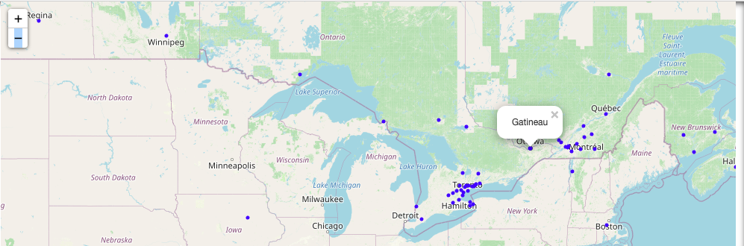

**3.1.2 Venues dataset**

The venues dataset of Canada municipalities includes: the municipality name, municipality longitude, municipality latitude, the venue name, venue longitude, venue latitude and venue category. After combining the venue dataset with the master dataset as explained in section 2, the venue dataset was explored using the following descriptive statistics charts and summary information printouts:

* A printout of sample venue dataset and its attributes (Table 6).
* Venues raw dataset summary information (Figure 5). This dataset includes the venue information before dropping the duplicate rows. This figure shows that the venue raw dataset includes 8671 records.
* Venues dataset summary information printout (Figure 6). This dataset includes the venue information after dropping the duplicate rows. This figure shows that the venue raw dataset includes 8571 records.
* A bar chart that depicts the total number of venues for each Canadian municipality (Figure 7)
* Venues dataset descriptive statistics (Figure 8)
* Venues dataset logarithmic scale histogram (Figure 9)

**Table 6 - Sample of the venue dataset and its attributes**

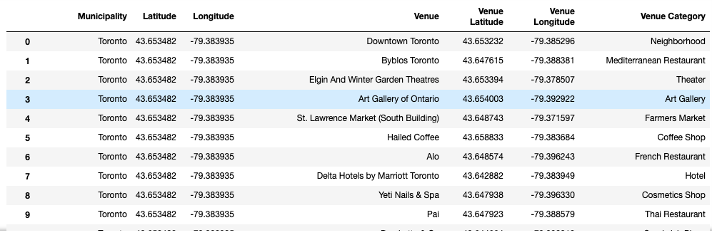

**Figure 5 – Venues raw dataset summary information**

**(8671 Canadian municipalities before dropping the duplicate rows)**

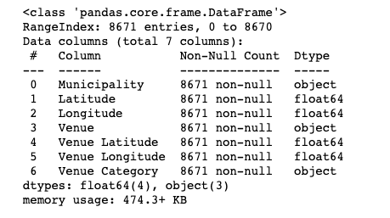

**Figure 6 – Venues dataset summary Information**

**(8571 Municipalities after dropping the duplicate rows)**

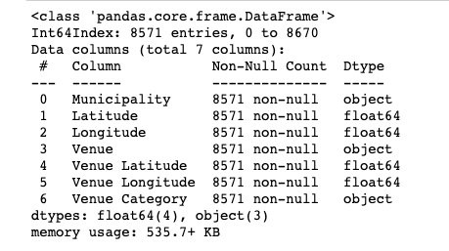

**Figure 7 – Sample of the total number of venues for each Canadian municipality**

**(after dropping the duplicate rows)**

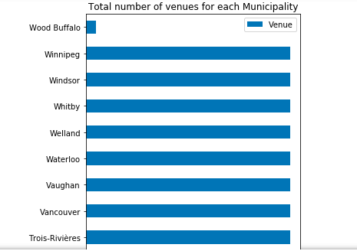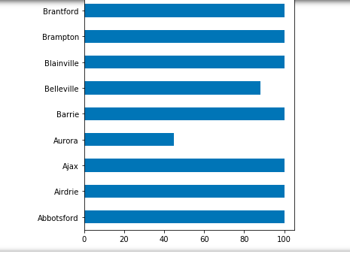

**Figure 8 – Venues dataset descriptive statistics**

**(after dropping the duplicate rows)**

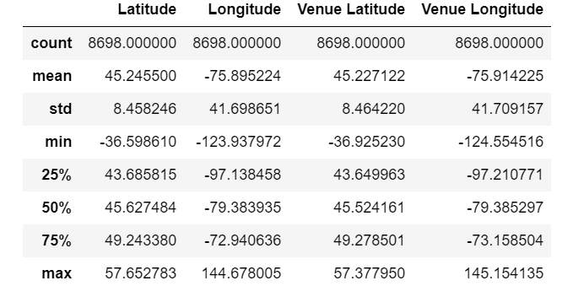

**Figure 9– Venues log-scale histogram**

**(after dropping the duplicate rows)**

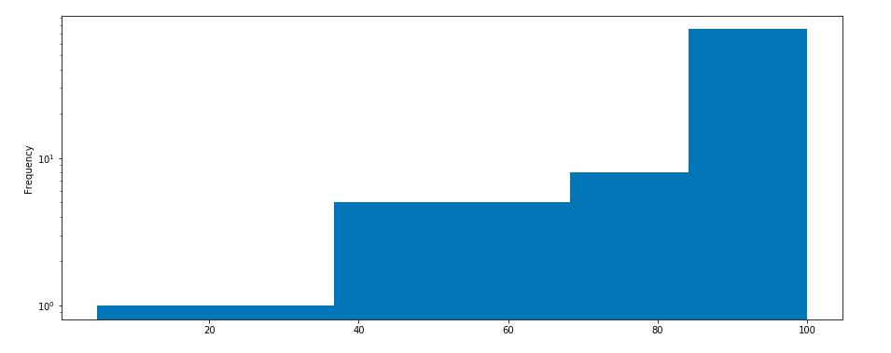

**3.1.3 Exploring the features dataset**

The features dataset is a subset of the venues’ dataset. It includes the hotels venues, the bakeries venues and grocery stores venues. It consists of 761 cleansed data records. These records were obtained by filtering the 8698 records of venues dataset to obtain only the venues belonging to the hotels, bakeries and the grocery stores categories. The selected features dataset was explored using the following descriptive statistics charts and summary information printouts:

* A bar chart that shows the total number of each venue category in the selected features dataset (i.e. the hotels, grocery stores and bakery), and a printout of the total number of all venues in the selected features dataset (Figure 10).

**Figure 10 - Number of venues in each feature category,**

**and total number of venues in the features dataset (2220)**

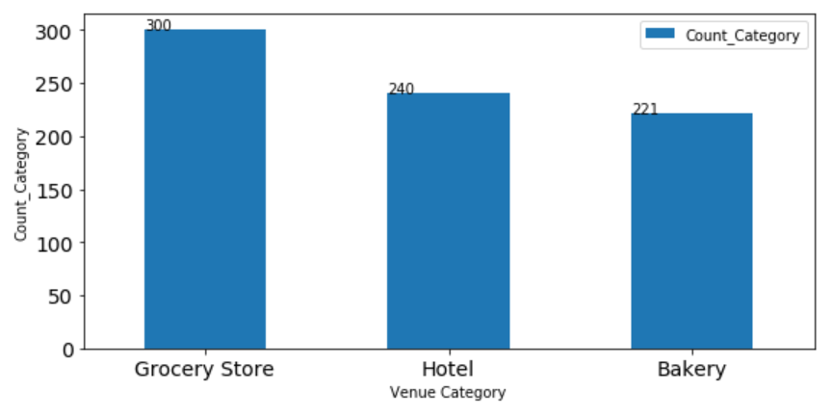

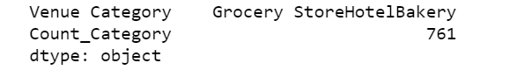

* Four histograms that depict characteristics of the selected features dataset, i.e. the hotels, grocery stores, bakeries and the total number of selected features (Figure 11).

**Figure 11 - Selected features dataset histograms**

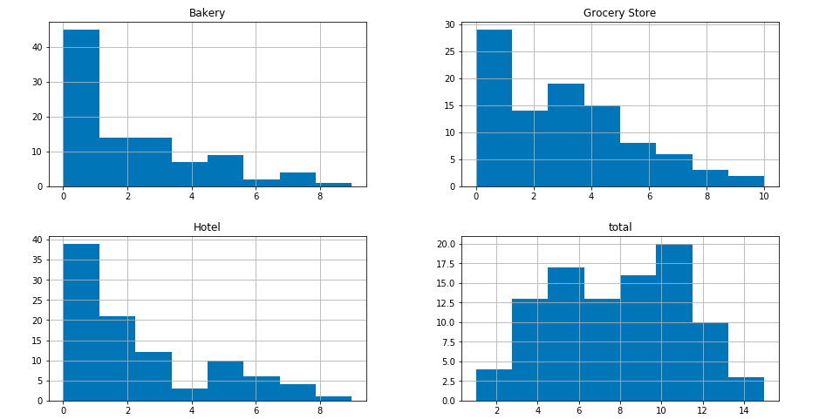

**3.1.4 Exploring the relationship between the municipalities and the features**

The relationship between the municipalities and each feature in the features dataset is explored using the following descriptive statistics charts, maps and summary information printouts:

* A bar chart that shows the relationship between the municipalities and each feature in the features dataset (i.e. the number of hotels, the number of grocery stores and the number of bakeries in the municipalities). This bar chart is shown in Figure 12.
* A map that shows the density of total number of venues in each municipality (i.e. the number of hotels + the number of grocery stores + the number of bakeries). In order to show the density of venue distribution across the municipalities, the data was classified into three type of densities (low density, medium density and high density) and a colour coding was used to depict each type of density on the map (Figure 13).

**Figure 12 - Relationship between the municipality and each selected feature**

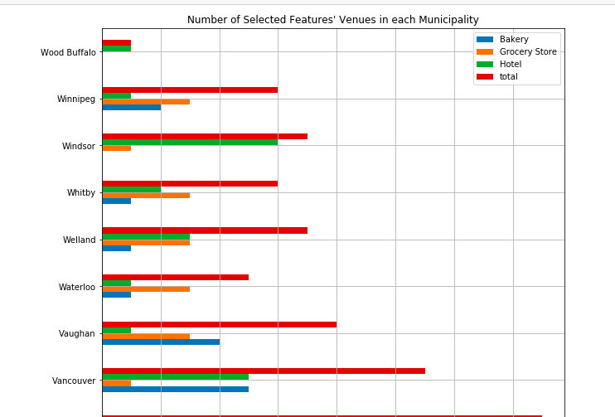

**Figure 13 - Density of total number of venues in each municipality**

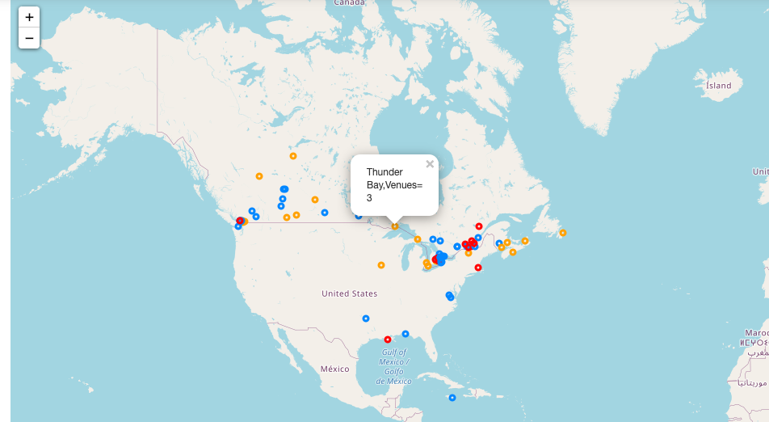



* A map that shows the density of the bakeries in each municipality. In order to show the density of the bakerys’ distribution across the municipality, the data was classified into three type of densities (low density, medium density and high density) and a colour coding was used to depict each type of density on the map (Figure 14).

**Figure 14 - Density of total number of bakeries in each municipality**

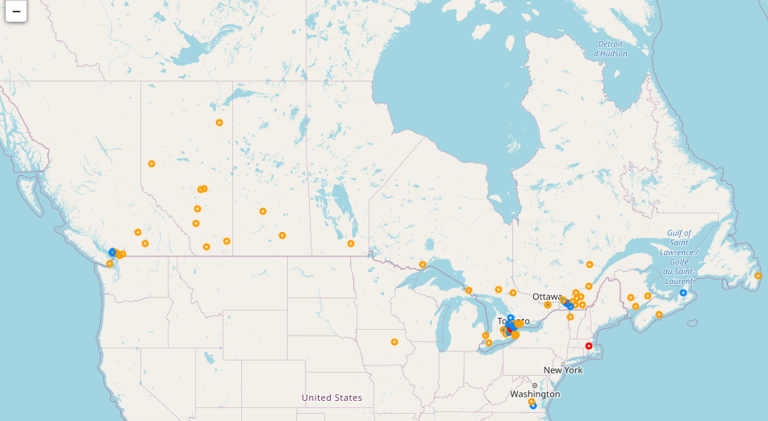



* A map that shows the density of the hotels in each municipality. In order to show the density of the Hotels distribution across the municipality, the data was classified into three type of densities (low density, medium density and high density) and a colour coding was used to depict each type of density on the map (Figure 15).

**Figure 15 - Density of total number of Hotels in each municipality**

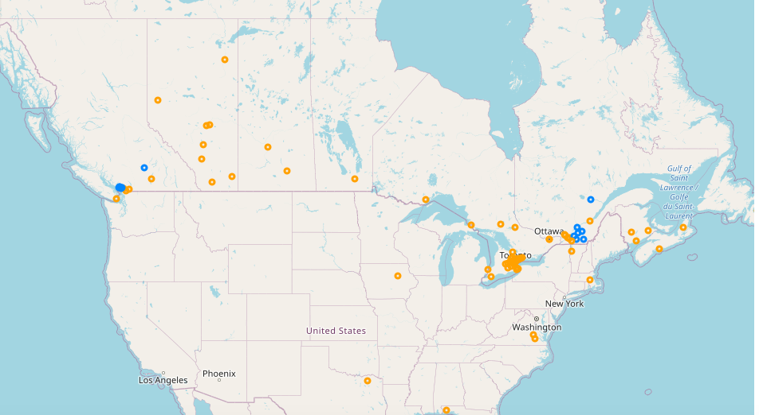



* A map that shows the density of the Grocery Store in each municipality. In order to show the density of the Grocery Stores distribution across the municipalities, the data was classified into three type of densities (low density, medium density and high density) and a colour coding was used to depict each type of density on map (Figure 16).

**Figure 16 - Density of total number of Grocery Stores in each municipality**

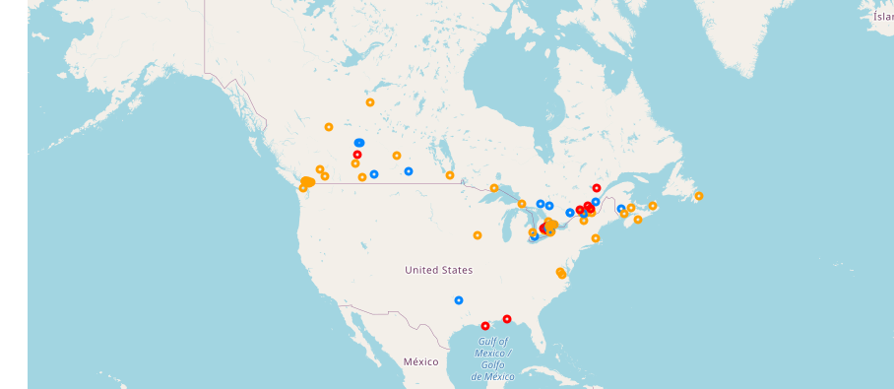



To verify the correctness on the data displayed on the above mentioned four maps, the features data of Montreal municipality was extracted from the features dataset and displayed in the form of a data frame and compared with the corresponding data displayed on the maps. Figure 17 depicts the features data of Montreal municipality in a data frame and the corresponding number of features in four separate maps.

**Figure 17.A – The features data of Montreal municipality**

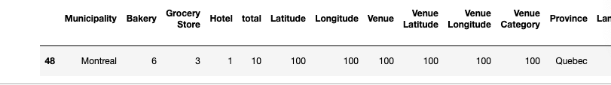

**Figure 17.B – The corresponding maps of features data of Montreal municipality**

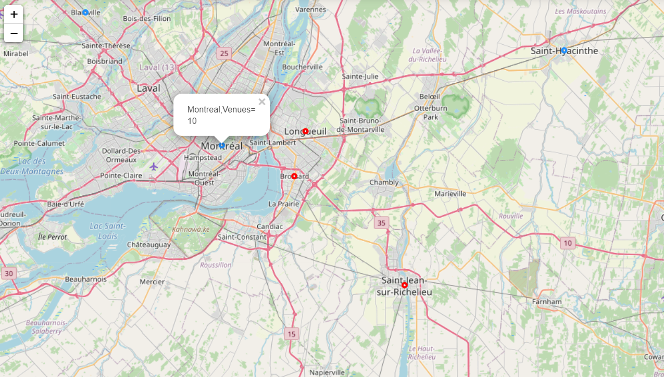

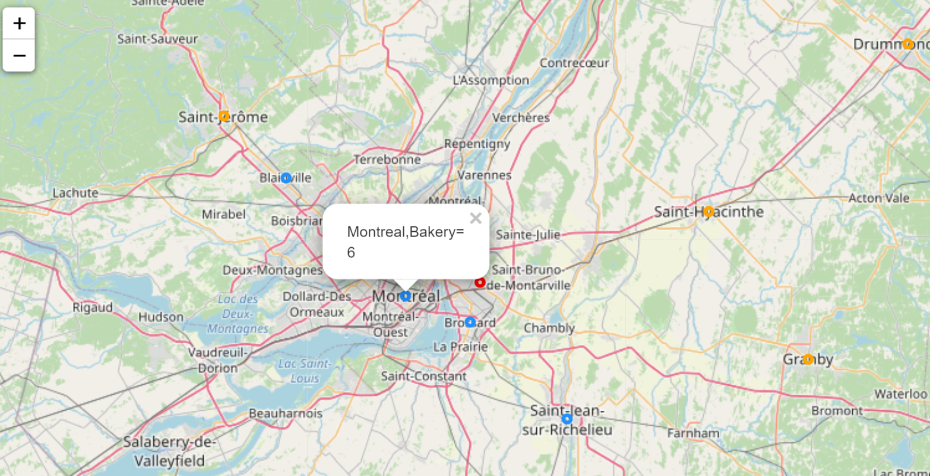

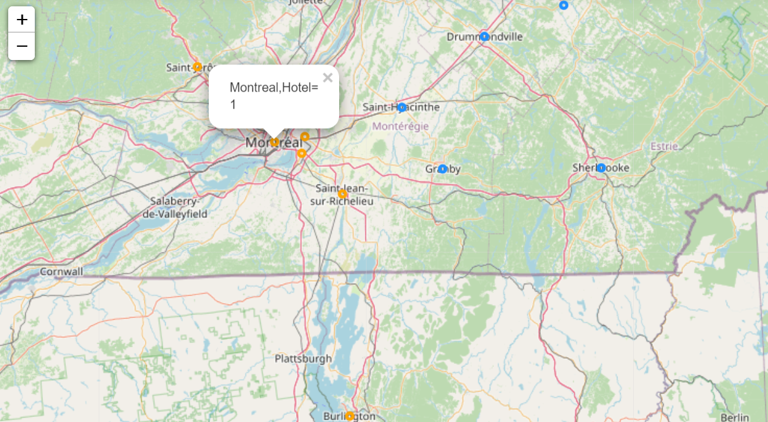

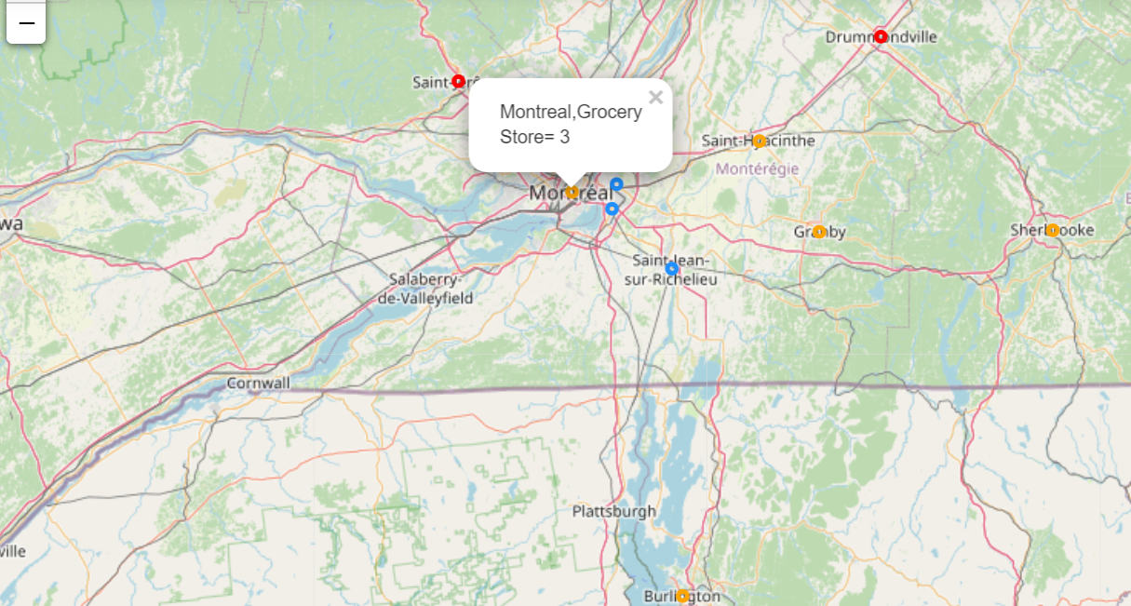

**3.2 Inferential statistical testing**

No inferential statistical testing was needed since the required datasets were fully acquired through the Internet. The datasets were then cleansed, filtered and prepared to generate the full master dataset and the full features dataset required for building the clustering models.

* 1. **Model selection**
     1. **Selecting the Machine Learning Technique**

Table 7 summarizes the most important predictive and descriptive machine learning techniques.

It also shows why I selected the clustering technique to solve this business problem.

**Table 7 – Justification of selecting the clustering technique**

| **No** | **ML Technique** | **Analytical Approach** | **Description** | **Selected?** | **Reason** |
| --- | --- | --- | --- | --- | --- |
| 1 | Regression | Predictive | Supervised learning technique used for predicting a continuous value | No | * The business problem solution is descriptive in nature. * The data is unlabelled, and the process must be unsupervised |
| 2 | Classification | Predictive | Supervised learning technique used for predicting the class or category of a case | No | * The business problem solution is descriptive in nature. * The data is unlabelled, and the process must be unsupervised |
| 3 | Recommender systems | Predictive | Supervised or unsupervised learning technique used to offer relevant suggestions to users. Categorized as either a collaborative filtering or a content-based system | No | * The business problem solution is descriptive in nature. * The data is unlabelled, and the process must be unsupervised * No data for similar companies’ performance is available |
| 4 | Clustering | Descriptive | Unsupervised learning technique used for finding groups of similar cases, for example, can be used  for customer segmentation | **Yes** | * The business problem needs to find similar municipalities (i.e. market segments) in order to target them by specific operations teams in the company * The data is unlabelled, and the process must be unsupervised |
| 5 | Association | Descriptive | A learning technique (commonly unsupervised) used for finding items or events that often co-occur | No | * The business problem does not need finding items that often co-occur |
| 6 | Anomaly detection | Descriptive | Supervised, unverified or semi-supervised learning technique used for discovering abnormal and unusual cases | No | * The business problem does not need to detect anomalies |
| 7 | Sequence mining | Descriptive | A learning technique (commonly unsupervised) used for determining sequential patterns in data | No | * The business problem does not need to detect sequential patterns in data |
| 8 | Dimension reduction | Descriptive | Unsupervised learning technique used for reducing the size of data | No | * No need to reduce data size. Data size is not too large (100 municipalities and 761 venues). |

* + 1. **Selecting the Machine Learning Model**

Having selected the clustering technique, the second step in my model selection approach was to decide which clustering model is suitable for solving the business problem.

Table 8 summarizes the most important clustering models and shows why I selected the K-Means clustering model and the agglomerative clustering model to solve the business problem.

**Table 8 – Justification of clustering models selection**

| **No** | **Clustering Model** | **Description** | **Selected?** | **Reasons** |
| --- | --- | --- | --- | --- |
| **1** | K-Means clustering | It divides the data into K non-overlapping  subsets or clusters without any cluster  internal structure or labels (unsupervised algorithm) | Yes | * It is an easy and simple model, with fewer hyperparameters than the other clustering algorithms (we mainly need to specify the K value). * In our case, there is no difficulty in determining the value of K since a specific number of market segments (3) is already predefined by the management of company * We have a medium size dataset (100 municipalities and 761 venues), and this algorithm is optimal for dealing with medium or large size datasets * In our case, there is no large computation cost during runtime especially because the sample size is not large (100 municipalities and 761 venues). * In our case, we do not need to care about the complexity associated with providing a proper scaling (for fair treatment among features) since all the features are homogeneous and hence no scaling is needed (each feature represents the number of specific category of venues in the municipality). * In our case, we are not interested in the notion of outliers (since every single municipality must be classified in a distinct market segment). Therefore, using this algorithm which has no notion of outliers, does not represent a problem in our case. * The variance of the features dataset variables has almost the same value across the three features dataset values |
| **2** | Hierarchical clustering | It builds a hierarchy of clusters where each node is a cluster consisting of the clusters of its daughter nodes. | Yes | * Hierarchical clustering is normally used for small size datasets. For the size of our dataset (100 municipalities), it is not so difficult to use the dendrogram. * For the size of our dataset, K-means is more efficient. Hierarchical clustering takes longer computation times in comparison with K-means. However, in our case, the algorithm would not take long computation times because the size of the dataset is not too big. |
| **3** | Density-based spatial clustering of applications with noise  (DBSCAN) | It groups together points that are closely packed together (points with many [nearby neighbors](https://en.wikipedia.org/wiki/Fixed-radius_near_neighbors)) | No | * DBSCAN does not fit our business problem (in which every single municipality must be classified in a distinct market segment) since DNSCAN has the notion of noise (outliers) and it ignores less dense areas or noises based on the two parameters: radius and minimum points * DBSCAN needs a careful selection of its parameters. The radius and the minimum points parameters are indeterministic in our case, since no constraints are imposed by the company management on them. * DBSCAN is much slower than K-Means * DBSCAN doesn’t work well over clusters with different densities |

* + 1. **Applying the K-Means clustering model to the business problem**

Based on the justification described in the previous section, I applied the K-Means clustering model to segment the company potential market into three distinct segments. The model was applied using the parameters shown in Table 9 and the datasets described in Table 10. The obtained results are described in section 4.

**Table 9 – Parameters used in the K-Means Clustering model**

|  |  |  |
| --- | --- | --- |
| **No** | **Parameter** | **Value** |
| **1** | Number of clusters (K) | K=3  i.e. we have 3 clusters (since three market segments are specified as business requirement in the problem definition section (Section 1) |
| **2** | Distance calculation method | Euclidean Distance (default) |

**Table 10 – Description of the used datasets**

|  |  |  |  |  |
| --- | --- | --- | --- | --- |
| **No** | **Dataset** | **Dataset Type** | **Description** | **Number of records** |
| 1 | Municipalities (raw data) | Master dataset | Raw data of the municipalities (extracted from the Wikipedia website) | 100 |
| **2** | Municipalities (cleansed data) | Master dataset | Data of municipalities that have venue information in the Four-Square database. | 100  (all municipalities already have data in the Four-Square database) |
| **3** | Municipalities venues | Features dataset | Data of the venues belonging to the 100 municipalities | 761 |

* + 1. **Applying the hierarchical agglomerative clustering model to the business problem**

Based on the justification described in the previous section, I have also applied the hierarchical agglomerative clustering model to segment the company potential market into three distinct segments. The model was applied using the parameters shown in Table 11 and the same datasets described before in Table 10. The obtained results are described in section 4.

**Table 11 – Parameters used in the hierarchical agglomerative clustering model**

|  |  |  |
| --- | --- | --- |
| **No** | **Parameter** | **Value** |
| **1** | Number of clusters (K) | K=3 |
| **2** | Distance calculation method | * Single * Complete * Average |

1. **Results** 
   1. **Results of the K-Means clustering model**

Table 12 shows the number of municipalities in each of the three clusters (i.e. in each market segment), and Table 13 shows the centroid value of each of them.

**Table 12 – Number of municipalities in each market segment**

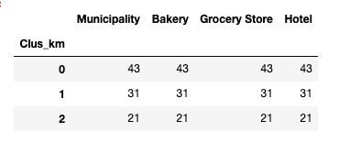

**Total = 100 municipalities**

**Table 13 – Centroid value of market segments**

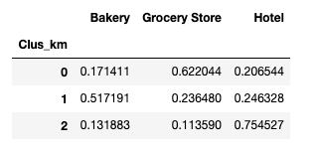

Figures 18,19, 20 and 21 show the distribution of municipalities based on the frequency of occurrence of Bakeries, Hotels and Grocery Stores venues in each municipality.

**Figure 18 – Distribution of municipalities based on the frequency of occurrence of**

**Bakery and Grocery Store venues**

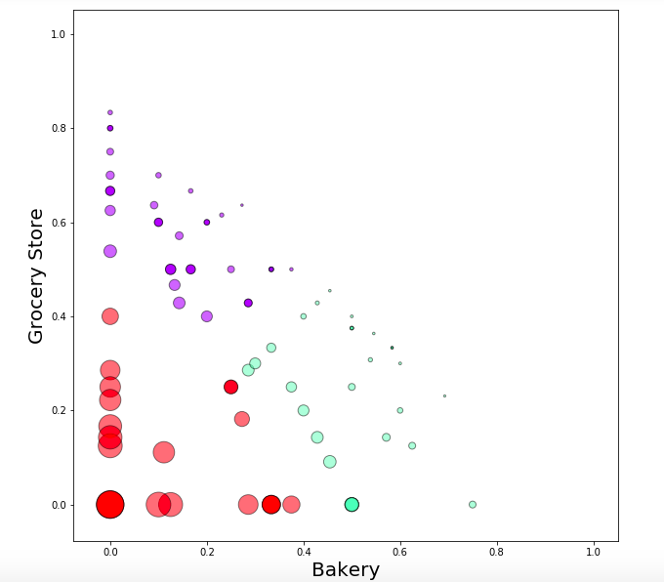

**Figure 19 – Distribution of municipalities based on the frequency of occurrence of**

**hotel and Grocery Store venues**

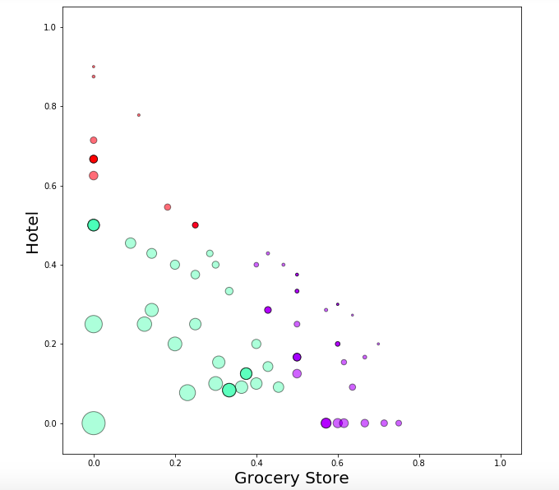

**Figure 20 – Distribution of municipalities based on the frequency of occurrence of**

**Bakery and Hotel venues**

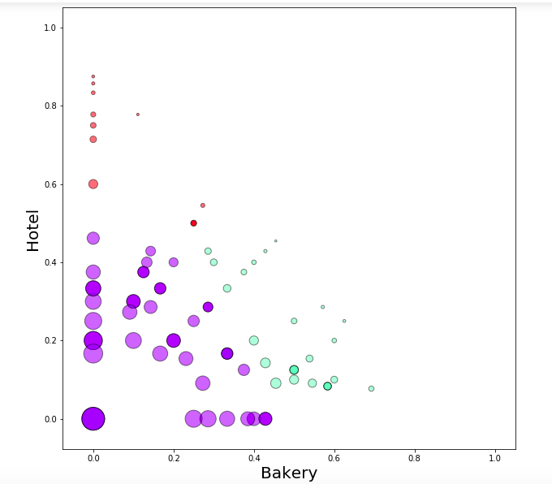

**Figure 21 – Distribution of municipalities based on the frequency of occurrence of**

**Bakery, hotel and Grocery Store venues**

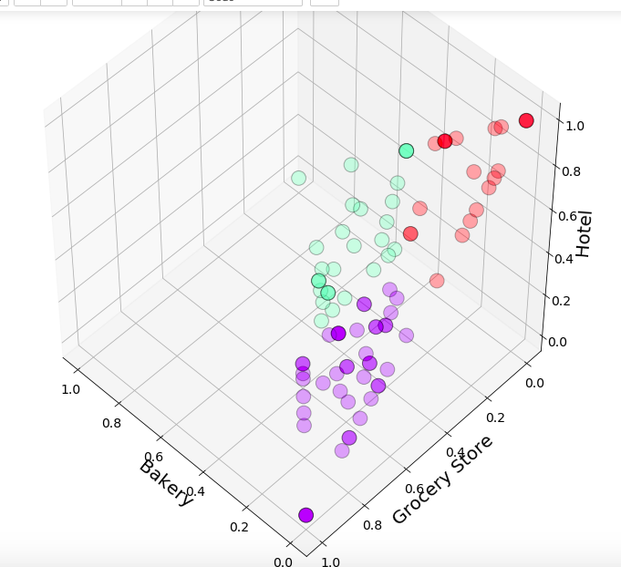

Table 14 shows the number of Grocery Stores, Hotels and Bakeries in each market segment. The same results are illustrated by the bar chart in Figure 22. Figure 23 depicts the density of Grocery Stores, Hotels and Bakeries in each market segment.

**Table 14 – Number of Bakery, Grocery Stores and Hotels in each market segment**

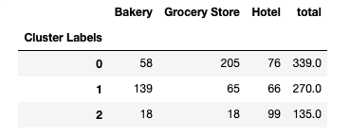

**Figure 22 – Number of Grocery Stores, hotels and Bakeries in each market segment**

Market Segment 1

Market Segment 2

Market Segment 3

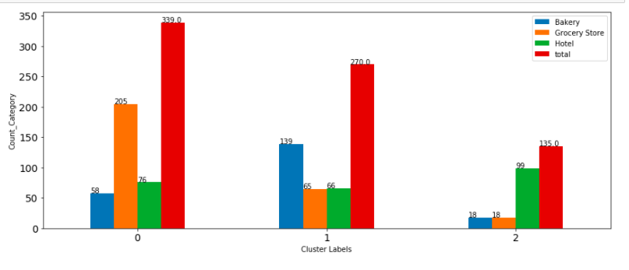

**Figure 23 – Density of Bakery, Grocery Store and Hotel in each market segment**

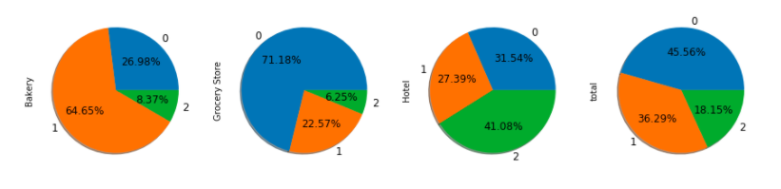

Figure 24 shows the distribution of Canadian municipalities on the three market segments, and Tables 15, 16 and 17 show sample reports of the municipalities of each market segment.

**Figure 24 – Distribution of Canadian municipalities on the three market segments**

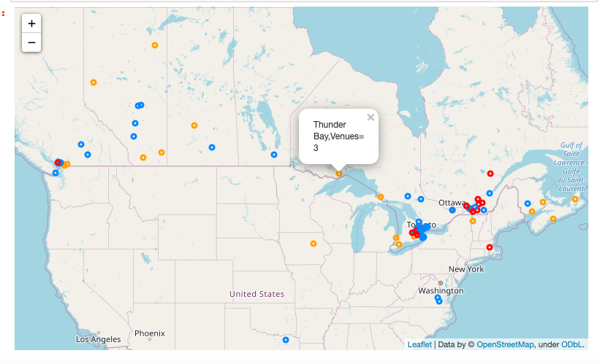

Cluster 0 (Market Segment 1)

Cluster 1 (Market Segment 2)

Cluster 2 (Market Segment 3)

**Table 15 – Report sample: Canadian municipalities of market segments 1**

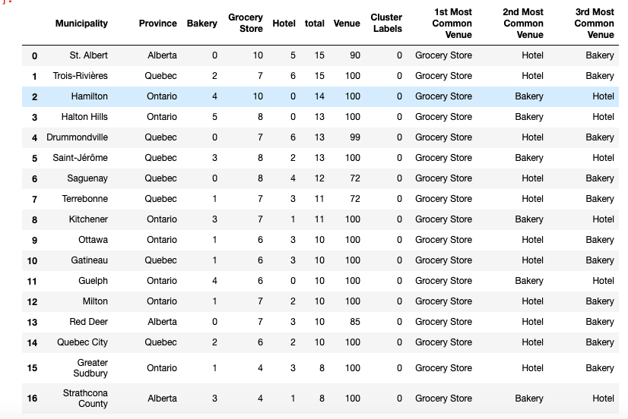

**Table 16 – Report sample: Canadian municipalities of market segments 2**

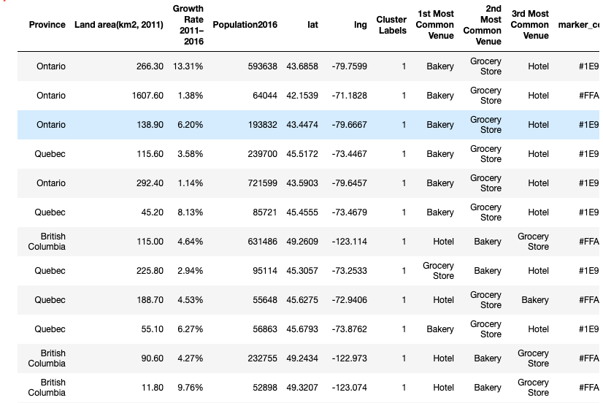

**Table 17 – Report sample: Canadian municipalities of market segment 3**

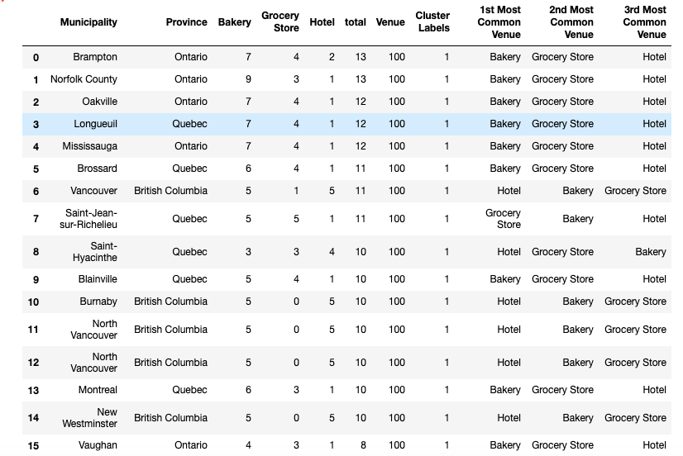

* 1. **Results of the hierarchical agglomerative clustering model**

When I applied the hierarchical agglomerative clustering model on this business problem, I obtained the same results generated from the K – Means clustering model. Also, the results of the hierarchical agglomerative clustering model did not change when I used different options for the distance calculation method (i.e. the single, complete and average distance calculation methods). Figure 25 shows the results of applying the hierarchical agglomerative clustering model to the business problem (in the form of a dendrogram.)

**Figure 25 – Result of the hierarchical agglomerative clustering model**

**(Dendrogram)**

`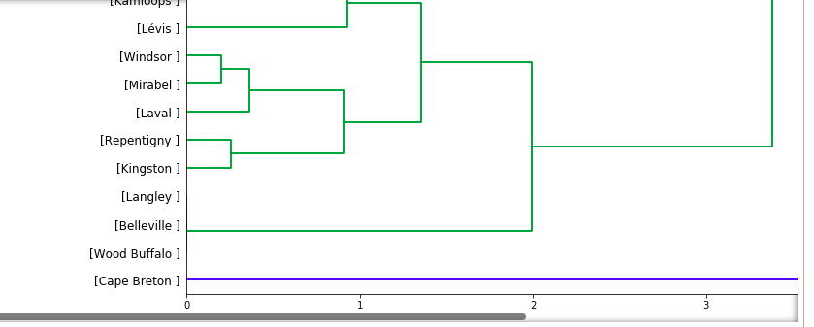

1. **Discussion**

The results obtained from the K-Means clustering algorithm and the agglomerative clustering algorithm are identical, and both algorithms have provided a good solution to the business problem. As shown in Figures 22 and 23 we can notice that:

* Market segment 1 is a “Grocery Stores oriented” market segment: About 72% of the Canadian grocery stores’ target market belongs to the municipalities of this market segment. The remaining 28% of grocery stores market is shared by the bakery and hotel market segments with a percentage of 21% and 6% respectively.
* Market segment 2 is a “Bakery oriented” market segment: About 62% of the bakery target market belongs to the municipalities of this market segment. The remaining bakery target market is shared between the grocery store and hotel 3 with a share of 31% and 8% respectively.
* Market segment 3 is a “Hotel oriented” market segment About 42% of the hotels’ target market belongs to the municipality of this market segment. The remaining 58% of the hotels’ target market is shared between the grocery stores and bakery with a percentage of almost 31% and 27% respectively.

It is quite interesting to note that the total number of potential customers in each market segment is somewhat different (339, 270 and 135 for market segments 1,2, and 3 respectively). Based on this data, the management of the company is advised to consider adjusting its organization structure and uplifting its human capital capabilities in order to be able to successfully implement the new marketing strategy and cope with the requirements of the new Canadian market.

1. **Conclusion**

In this study, I used the K-Means and the Agglomerative clustering machine learning techniques to segment the new Canadian market of Senses Coffee company I identified the frequency of occurrence of Hotel, Grocery Store and Bakery as the most important features that affect the segmentation of this potential market. I built both K-Means clustering model and Agglomerative clustering model to build the market segments. These models are very useful in helping the company management in several ways. For example, it could help develop a new organization chart and plan the human capital and competencies necessary to implement the company’s new marketing strategy.

**Appendix I –Example of the Canadian municipalities in the Wikipedia page**

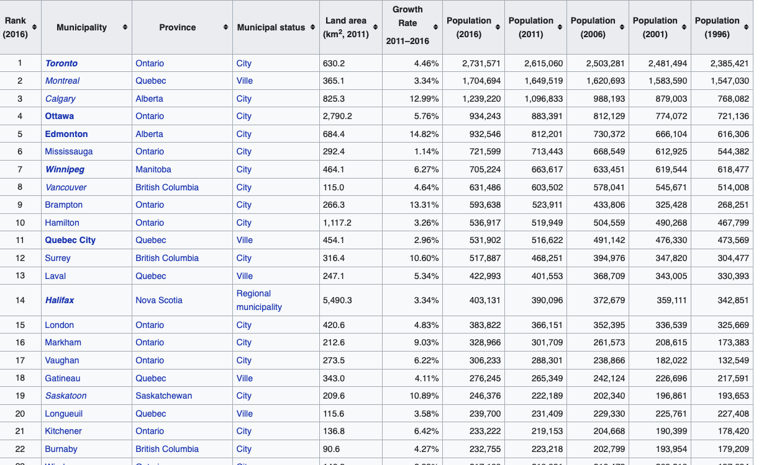

**Appendix II – Example of Canadian municipalities’ Geo-Location data**

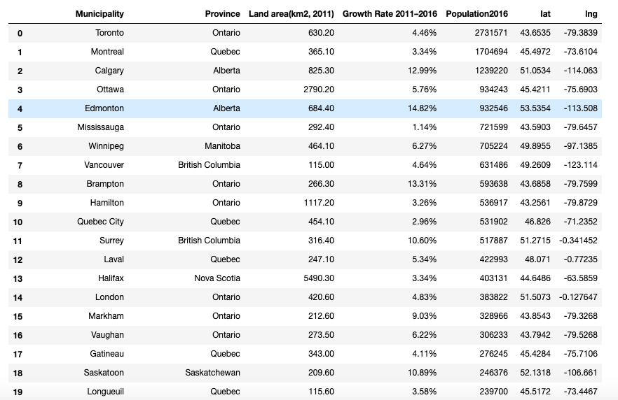

**Appendix III – Example of potential customers data** 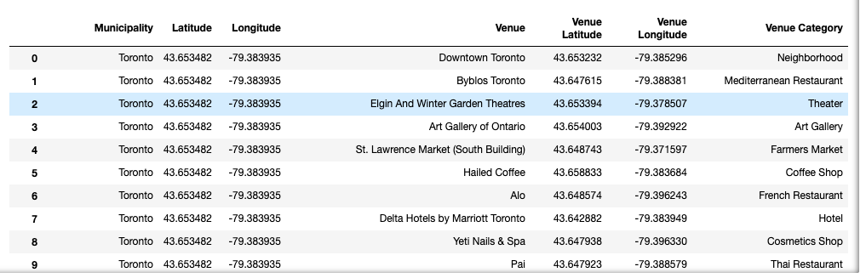

**Appendix IV – Example of Canadian GIS data**

